1) The test for the presence of Ag+ in an unknown solution involves the treatment of the silver–ammonia complex with dilute hydrochloric acid. The appearance of a white precipitate at this point indicates the presence of silver ion in the original sample. The net ionic equation that represents this test is……
a. Ag(NH₄)₄⁺ + 4 H⁺ → Ag(s) + 4 NH₄⁺
b. Ag(NH₄)₄⁺ + Cl– →AgCl(s) + 4 NH₄⁺
c. Ag(NH₃)₄⁺ + 4 HCl → AgCl(s) + 4 NH₄⁺ + 3 Cl–
d. Ag(NH₃)₂⁺ + Cl– → Ag(NH₃)₂Cl(s)
e. Ag(NH₃)₂⁺ + 2 H⁺ + Cl– → AgCl(s) + 2 NH₄⁺

2) The solubility of CuI is 2x10^{–6} molar. What is the solubility product constant, K_{sp}, for CuI?
a. 1.4 x 10^{–3} c. 4 x 10^{–12} e. 8 x 10^{–18}
b. 2 x 10^{–6} d. 2 x 10^{–12}

4) A solution is known to contain an inorganic salt of one of the following elements. The solution is colorless. The solution contains a salt of….
a. Cu c. Fe e. Zn
b. Mn d. Ni

5) MnS(s) + 2 H⁺ _ Mn²⁺ + H₂S(g)
At 25_C the solubility product constant, K_{sp}, for MnS is 5x10^{–15} and the acid dissociation constants K₁ and K₂ for H₂S are 1x10^{–7} and 1x10^{–13}, respectively. What is the equilibrium constant for the reaction represented by the equation above at 25_C?
a. 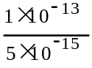 d. 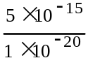
b. 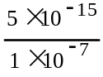 e. 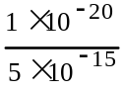
c. 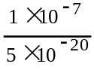

Write the net ionic equation for the following

7) Excess sodium cyanide solution is added to a solution of silver nitrate forming a complex ion

8) Excess concentrated aqueous ammonia is added to a solution of nickel(ii) bromide forming a complex ion

9) Solid silver chloride is added to a solution of concentrated hydrochloric Acid forming a complex ion

13. Barium sulfate is LEAST soluble in a 0.01–molar solution of which of the following?
(A) Al₂(SO₄)₃ (B) (NH₄)₂SO₄
(C) Na₂SO₄ (D) NH₃
(E) BaCl₂

14. What is the net ionic equation for the reaction that occurs when aqueous copper(II) sulfate is added to excess 6–molar ammonia?
(A) Cu²⁺ + SO₄^{2–} + 2 NH₄⁺ + 2 OH– −−> (NH₄)₂SO₄ + Cu(OH)₂
(B) Cu²⁺ + 4 NH₃ + 4 H₂O −−> Cu(OH)₄^{2–} + 4 NH₄⁺
(C) Cu²⁺ + 2 NH₃ + 2 H₂O −−> Cu(OH)₂ + 2 NH₄⁺
(D) Cu²⁺ + 4 NH₃ −−> Cu(NH₃)₄²⁺
(E) Cu²⁺ + 2 NH₃ + H₂O −−> CuO + 2 NH₄⁺

15. The following equilibrium was established by combining equal volumes of 0.1 M AgNO3(aq) and 0.1 M Fe(NO3)2(aq). Which of the following will shift the equilibrium to the right?
1. Adding 0.1 M AgNO3(aq).
2. Removing some Ag(s) by filtering the mixture.
3. Decreasing the Fe3+ concentration by another chemical reaction.
[A] 1 only
[B] 2 only
[C] 3 only
[D] 1 and 2 only
[E] 1 and 3 only

16. From a consideration of the reactions
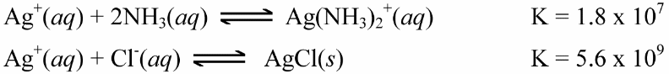
calculate the equilibrium constant for
[A] 1.0 × 10-17
[B] 3.2 × 10-3
[C] 1.0 × 1017
[D] 1.0 × 103
[E] 3.1 × 1016

17. The Ksp for Ag2CO3 is 8 × 10-12; what is the concentration of Ag+ in a Ag2CO3 solution that is 0.010 M in CO32-?
[A] 8 × 10-9 M
[B] 2 × 10-9 M
[C] 3 × 10-5 M
[D] 6 × 10-5 M
[E] 8 × 10-4 M

18. The solubility of PbSO4 is 0.041 g/L. Its molar mass is 303 g/mol. Its Ksp is
[A] 8.8 × 10-12.
[B] 1.7 × 10-8.
[C] 1.3 × 10-4.
[D] 1.7 × 10-3.
[E] 4.1 × 10-2.

19. The Ksp for AgI is 1 × 10-16. If you mix 500 mL of 1 × 10-7 M AgNO3 with 500 mL of 1 × 10-7 M NaI, then
[A] AgI will begin to precipitate.
[B] no precipitation will occur.
[C] 1 × 10-7 moles of AgI will form.
[D] silver nitrate will precipitate.
[E] sodium iodide will precipitate

